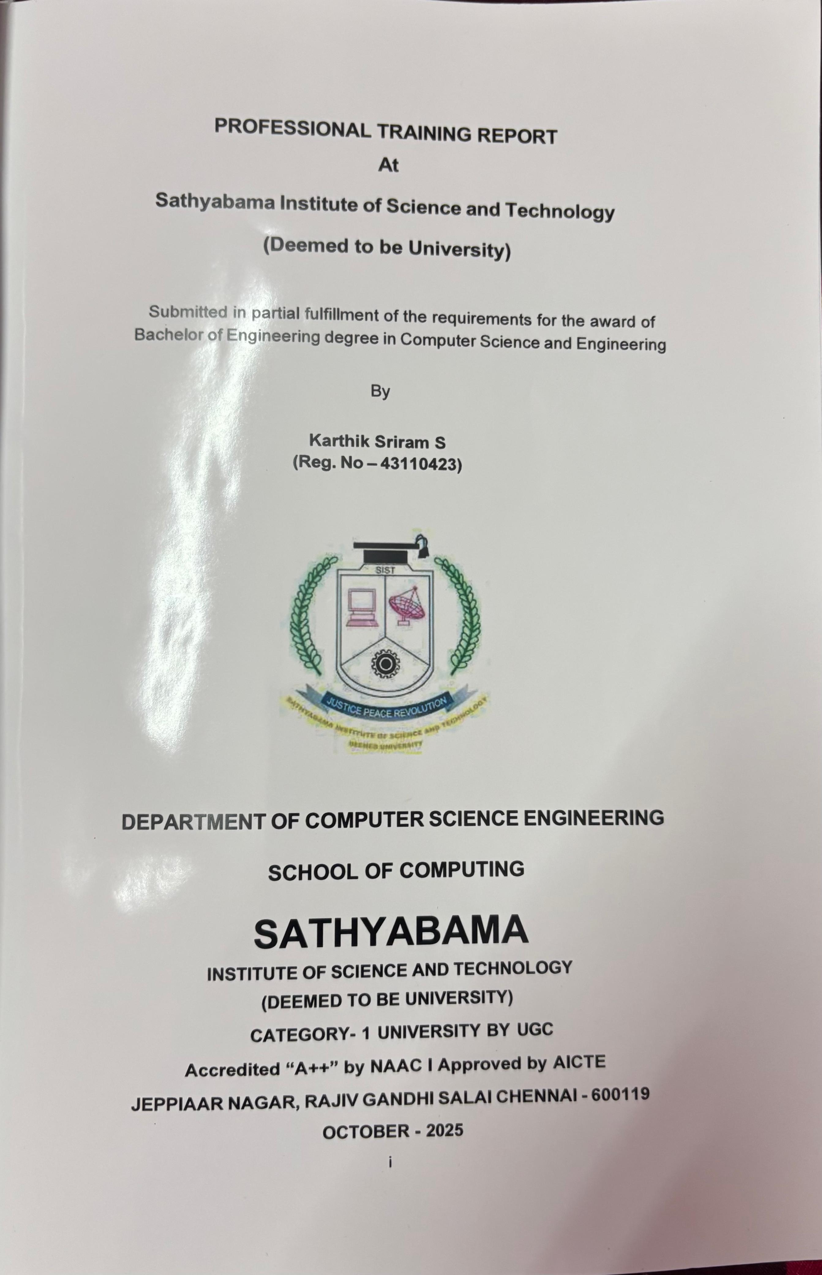
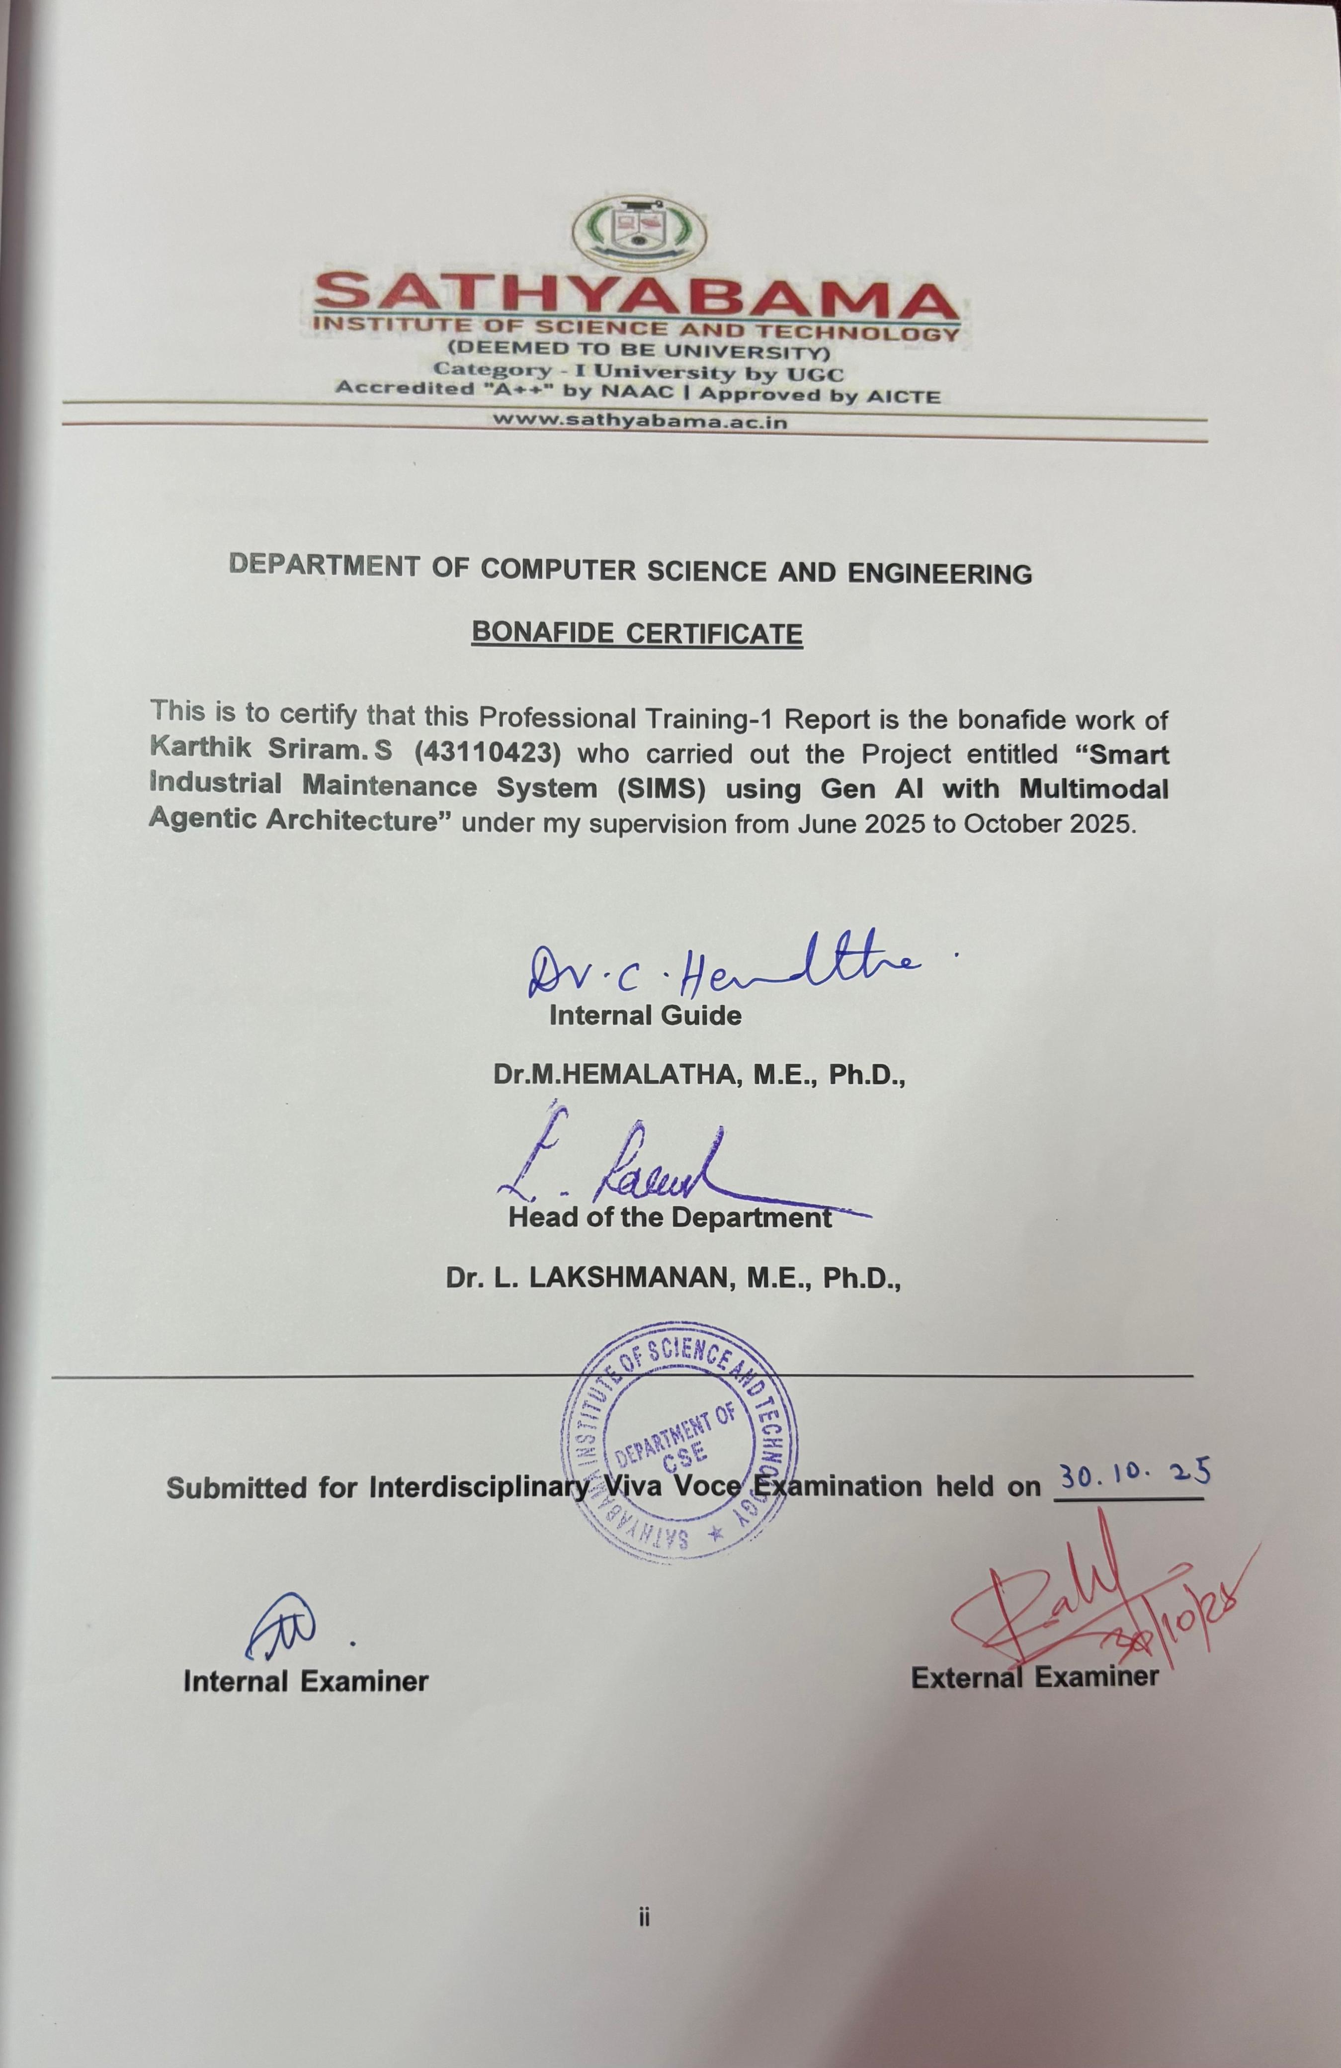

ACKNOWLEDGEMENT

I am pleased to acknowledge my sincere thanks to BOARD OF MANAGEMENT of Sathyabama Institute of Science and Technology for their kind encouragement in doing this project and for completing it successfully. I am grateful to them.
I convey my thanks to Dr. L. Lakshmanan, M.E., Ph.D., Dean & HoD., School of Computing, Department of Computer Science and Engineering for providing me with necessary support and details at the right time during the progressive reviews.
I would like to express my sincere and deep sense of gratitude to my Project Guide Dr.M.Selvi,M.E.,Ph.D.,for her valuable guidance, suggestions, and constant encouragement paved the way for the successful completion of my project work.
I wish to express my thanks to all Teaching and Non-teaching staff members of the Department of Computer Science and Engineering who were helpful in many ways for the completion of the project.

TRAINING CERTIFICATE

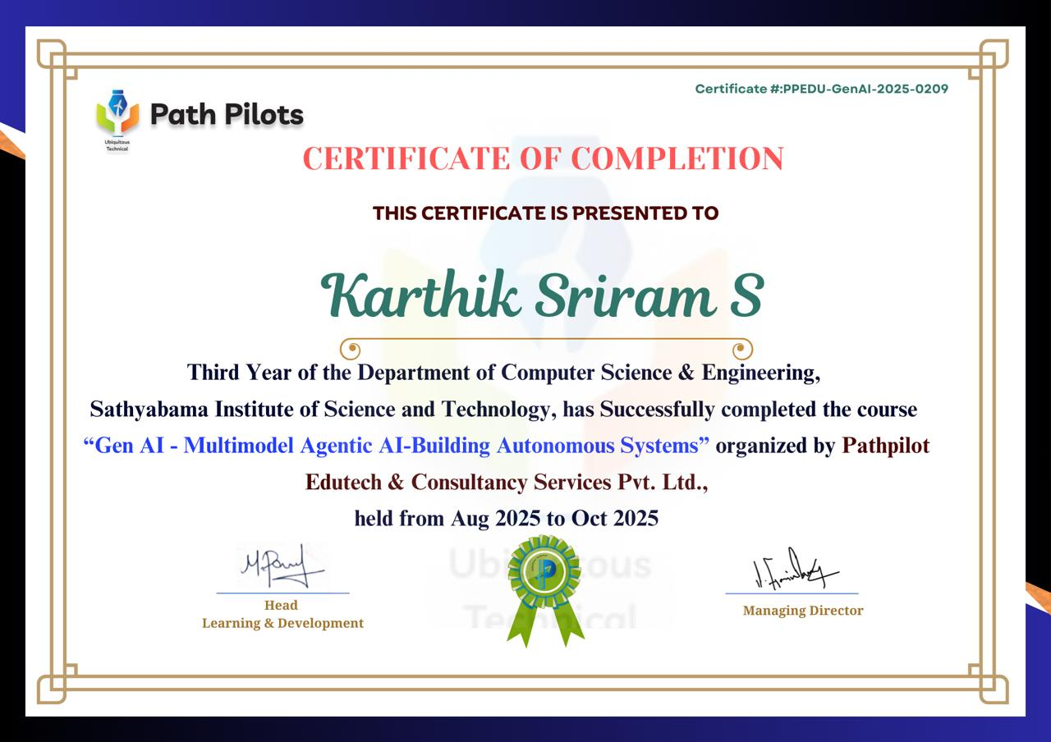

ABSTRACT

The Smart Industrial Maintenance System (SIMS) represents a paradigm shift in industrial maintenance by integrating Generative Artificial Intelligence (GenAI) within a multimodal agentic architecture. This innovative system harnesses the power of Internet of Things (IoT) sensors, edge computing, and advanced AI algorithms to facilitate real-time monitoring and predictive maintenance of industrial equipment. By collecting and analyzing data from diverse sources such as vibration, acoustic signals, and visual inputs, SIMS enables the early detection of anomalies and potential failures, thereby reducing unplanned downtimes and extending asset lifecycles. The incorporation of GenAI enhances the system's ability to generate predictive models and optimize maintenance schedules dynamically, adapting to changing operational conditions. Furthermore, the multimodal agentic architecture allows for seamless integration of various data modalities, providing a holistic view of equipment health and performance. This approach not only improves the accuracy of failure predictions but also supports human-AI collaboration by offering interpretable insights and actionable recommendations. The implementation of SIMS has demonstrated significant improvements in operational efficiency, cost reduction, and workforce empowerment. However, challenges such as data privacy concerns, integration complexities, and the need for specialized skills remain. Addressing these issues through robust cybersecurity measures, standardized protocols, and comprehensive training programs is essential for the widespread adoption of SIMS. In conclusion, SIMS offers a proactive, intelligent, and scalable solution to modern industrial maintenance challenges, paving the way for smarter, more resilient manufacturing environments.

.

TABLE OF CONTENTS

CHAPTER No. | TITLE | PAGE No.
1 | ABSTRACT  LIST OF FIGURES INTRODUCTION | v vii  1
  - INDUSTRIAL MAINTENANCE 2
  - INDUSTRY 4.0 MAINTENANCE 3
  - OBJECTIVES 3
  - SCOPE AND APPLICATIONS 4
- ANALYSIS 7
  - ROLE OF AI IN MAINTENANCE 7
  - MULTIMODEL AGENTIC ARCHITECTURE IN INDUSTRIAL CONTEXT
  - REQUUIREMENT ANALYSIS 9
- METHOD AND IMPLEMENTION 11
  - SYSTEM DESIGN AND ARCHITECTURE 11
  - GENERATIVE AI ROLE IN SIMS 12
  - AGENTIC WORKFLOW 13
  - INTEGRATION OF CLOUD AND EDGE COMPUTING
  - SECURITY AND DATA PRIVACY 15
  - DATA SOURCES 16
  - PROTOTYPE / SIMULATION SETUP 17

RESULTS & DISCUSSION 19
  - EXPECTED BENEFITS 19
  - PERFORMANCE INDICATOR 20
  - CASE SCENATIOS 20
  - HUMAN-AI COLLABORATION 21
  - LIMITATIONS AND CHALLENGES 21
- CONCLUSION 24
  - SUMMARY OF WORK 24
  - KEY FINDINGS 24
  - CONTRIBUTIONS OF SIMS 25
  - FUTURE ENHANCEMENTS 25
  - FINAL REMARKS 25
REFERENCES 26
 | LIST OF FIGURES
FIG NO | FIGURES | PAGE NO.
1 | SIMS IN GEN-AI | 22
2 | MULTIMODEL AI | 22
3 | AGENTIC AI FOR INDUSTRIAL SYSTEMS | 23
4 | GEN-AI AND MULTIMODAL CAPABILITIES | 23

CHAPTER – 1 INTRODUCTION

Smart Industrial Maintenance System (SIMS) using Generative AI with a Multimodal Agentic Architecture is an emerging paradigm that combines advanced artificial intelligence, autonomous agents, and multiple data modalities to transform maintenance operations in industrial settings. As industries evolve under Industry 4.0 and beyond, equipment reliability, uptime, and cost-efficiency have become central to competitive advantage. Traditional maintenance strategies—reactive or scheduled—often fail to prevent unexpected breakdowns or optimize resource allocation. SIMS aims to address these short-comings by leveraging real- time data, predictive insights, and autonomous decision-making.

At the core of SIMS, Generative AI (Gen AI) contributes capabilities such as generating diagnostic reports, simulating failure scenarios, designing corrective procedures, and even synthesizing maintenance schedules. Gen AI models can process historic maintenance logs, sensor data, operational manuals, etc., to reason about anomalies, root causes, and future risk. However, Gen AI alone is insufficient; it must be embedded within an agentic architecture— a system of autonomous agents that coordinate, plan, perceive, and act in concert toward maintenance goals.

A multimodal architecture means the system ingests and processes multiple kinds of data: e.g., vibration and temperature sensor signals; visual data such as images or video for checking physical wear; schematics or CAD models; textual documents like maintenance logs, manuals, and SOPs; possibly audio for machine sounds or alarms. By combining modalities, the system can develop a richer understanding of machine health, detect faults earlier, and more accurately diagnose issues.

In the agentic framework, there are specialized agents: a data acquisition agent for collecting and preprocessing sensor and visual inputs; a diagnostic agent for anomaly detection and root- cause analysis; a planning or scheduling agent to decide when and how maintenance should occur; a simulation or digital twin agent to model possible interventions and assess their impact; and possibly a procurement/inventory agent to ensure parts or tools are available. These agents communicate, share memory, retrieve knowledge from documents or manuals and adapt via feedback loops.

Industrial Maintenance

Industrial maintenance refers to all activities aimed at ensuring that machinery, equipment, and systems in manufacturing, energy, infrastructure, and other industrial settings remain operational, safe, and efficient over their lifetimes. Historically, maintenance was reactive: machines were repaired only after breakdowns occurred. Over time, this shifted to preventive maintenance, where routine inspections and regularly scheduled servicing were performed regardless of symptoms, with the goal of reducing unexpected failures.

With the advent of sensors, computing, and communications technologies, industries began to adopt condition-based maintenance and predictive maintenance. In these approaches, data on vibration, temperature, noise, lubrication, etc., are monitored to detect early signs of wear or abnormality.

The evolution of maintenance strategies has been driven by several pressures: the need to minimize unplanned downtime, control operational costs, meet regulatory and safety requirements, ensure product quality, and extend asset lifespan. As equipment becomes more complex and production demands grow tighter, failures not only disrupt output but also have cascading economic and safety consequences.

Another key element in modern industrial maintenance is the integration of digitization. Technologies such as the Industrial Internet of Things (IIoT), advanced sensors, cloud and edge computing, and big data analytics have enabled real-time monitoring and decision support. This digital transformation allows managers and maintenance engineers to continuously gather data, analyze trends, perform diagnostics, and make more informed decisions.

Over recent years, Artificial Intelligence and Machine Learning have started playing an increasingly important role. AI models can detect subtle patterns not obvious to humans, forecast failures, optimize maintenance schedules, and help manage resources (spare parts, labour) more effectively. These advances reduce downtime, improve reliability, and lower lifecycle costs.

Industry 4.0 Maintenance

Maintenance in Industry 4.0 shifts from merely fixing failures to proactively ensuring operational resilience through advanced technologies. Real-time monitoring via IoT sensors enables early detection of anomalies, thereby reducing unplanned downtime and associated costs. AI and machine learning support predictive and prescriptive maintenance, improving decision-making about when and how to intervene. Integration of digital twins and big data facilitates simulation and optimization of maintenance schedules, extending equipment lifespan. Maintenance 4.0 helps in optimizing spare parts inventory and workforce deployment, ensuring maintenance actions are timely and cost-efficient. Enhanced reliability and quality of production are achieved when equipment runs nearer to optimal conditions, reducing defect rates. Overall Equipment Effectiveness (OEE) improves significantly when maintenance is synchronized with production and resource scheduling. Environment and sustainability goals are supported as preventive maintenance reduces energy waste, lowers emissions, and minimizes material losses. Finally, the competitive landscape demands agility; companies that adopt smart maintenance strategies under Industry 4.0 often gain a strategic edge in cost, reliability, and customer satisfaction.

Objectives

The objectives of this project are defined to ensure that the Smart Industrial Maintenance System (SIMS) achieves measurable improvements and delivers value in industrial operations.

These are:
•To develop a multimodal data fusion framework to ingest, integrate, and preprocess diverse data sources — such as sensor signals (temperature, vibration, pressure), visual data (images, video), textual documents (manuals, maintenance logs), and audio alarms — so as to improve observability of equipment health.
•To build Generative AI models capable of diagnosing anomalies, inferring root causes,simulating failure scenarios, and proposing corrective maintenance actions automatically.

•To design and implement an agentic architecture comprising multiple autonomous agents responsible for tasks like monitoring, diagnostics, planning, scheduling, simulation, and inventory management, which communicate and collaborate efficiently.
•To incorporate predictive and prescriptive maintenance capabilities such that failures can be forecasted well before they occur, and maintenance interventions are optimized in terms of timing, cost, and resource allocation.
•To reduce unplanned downtime and maintenance costs by leveraging real-time monitoring and automated decision support, resulting in greater equipment availability and reliability.
•To enhance safety, regulatory compliance, and operational quality by early detection of safety-critical issues and adherence to standards through automated checks and alerts.
•To extend the useful life of assets by avoiding over‐maintenance and by timely interventions that prevent excessive wear, reducing lifecycle costs and capital replacement needs.
•To ensure that the system is interpretable, robust, and secure — i.e., that the Gen AI components provide explainable outputs, that agents behave reliably, and that data privacy, integrity, and cybersecurity are maintained throughout.
•To enable scalability and adaptability: so the system can be deployed across different industrial settings, different types of machinery, different scales (single machine to entire plant), and can adapt to evolving operating conditions and modalities.
•ςTo provide measurable performance metrics and key performance indicators (KPIs) such as Mean Time Between Failures (MTBF), Mean Time To Repair (MTTR), Overall Equipment Effectiveness (OEE), reduction in maintenance cost per unit time, and percent reduction in unplanned downtime, to validate project success.

Scope and Applications

The scope of this project encompasses the design, development, and deployment of a Smart Industrial Maintenance System (SIMS) that integrates Generative AI and a multimodal agentic framework to support predictive, prescriptive, and condition-based maintenance across various industrial environments.

It includes gathering and processing data from multiple modalities (vibration, temperature, pressure sensors; visual inspection via images or video; textual logs and manuals; audio diagnostics) to enable real-time anomaly detection, root cause analysis, remaining useful life estimation, and automated maintenance scheduling. The system will also involve agentic sub- systems for monitoring, diagnostics, planning/scheduling, simulation (digital twins), inventory/parts supply, and human-machine interaction.

1.4.1 Specific inclusions in scope:
- Implementation of data acquisition layer (sensor networks, imaging, text and document ingestion) and preprocessing (noise filtering, alignment, feature extraction).
- Development of generative AI models to infer anomalies, simulate failure scenarios, generate maintenance actions, and produce report outputs.
- Construction of an agentic orchestration layer, where autonomous agents collaborate (diagnostic, planning, inventory, scheduling agents etc.).
- Integration with existing industrial infrastructure (IoT devices, SCADA/MES systems) to allow seamless flow of data and actionable maintenance decisions.
- Provision of dashboards / user interfaces for operators, maintenance engineers, and management, including alerts, recommended actions, what-if simulations, and visualizations via digital twins.
- Ensuring robustness, interpretability, and security: the models should provide explainable outputs; data privacy and cybersecurity must be addressed.

1.4.2 Limitations / what is outside scope:
- Deep repair actions / actuation hardware: the system will generate guidance but actual physical maintenance will still require human technicians or existing machinery.
- Extremely rare failure modes for which there is insufficient data may not be predicted with high confidence.
- Full-scale deployment across multiple plants may require customization beyond the generic architecture.
- Edge-device resource constraints (latency, bandwidth) may limit real-time performance in some deployment sites.

1.4.3 Applications

SIMS can be applied in a variety of sectors and settings. Some key application areas are:
•Manufacturing plants: for machines on production lines – motors, conveyors, robotic arms – to reduce unplanned downtime, improve throughput and optimize maintenance schedules.
•Power generation and utilities: turbines, generators, boilers, transformers, lines – system health monitoring; early detection of degradation; optimized scheduling of inspections.
•Oil & Gas / Petrochemicals: pipelines, pumps, pressure vessels, rotating equipment; where failures are costly, and safety / environmental risks are high.
•Automotive sector: factory equipment, assembly robots, quality inspection tools; also possibly in connected vehicles / fleet maintenance for predictive diagnostics.
•Food & Beverage / Pharmaceuticals: critical equipment where hygiene regulations are stringent; early detection of defects or wear before product quality is compromised.
• Transportation / Heavy Equipment: locomotives, ships, aircraft maintenance support systems; remote monitoring and diagnostics in challenging or remote environments.
• Energy industry renewables: wind turbines, solar tracking mechanisms, battery systems, where failures may be remote or hard to service, making predictive maintenance especially valuable.
• Facility management and infrastructure: HVAC systems, elevators, building services; critical systems in large infrastructure that benefit from predictive monitoring.

The project aims that by applying SIMS in one or more of these domains, measurable benefits will be demonstrated: reductions in maintenance cost, improvements in asset uptime, greater safety and compliance, optimized inventory / parts usage, and enhanced lifecycle management.

CHAPTER – 2 ANALYSIS

The integration of Generative AI into industrial maintenance introduces significant challenges, particularly in data quality and system compatibility. Industrial environments often produce noisy, incomplete, or inconsistent data across various modalities, such as sensor readings, maintenance logs, and visual inspections. This data heterogeneity can complicate the development of reliable predictive models. Moreover, legacy systems prevalent in many industries may lack the necessary infrastructure to support advanced AI technologies, leading to integration difficulties and potential system incompatibilities.

Furthermore, the deployment of Generative AI in maintenance tasks raises concerns regarding model accuracy and interpretability. Instances of AI "hallucinations," where models generate plausible but incorrect information, can undermine trust in AI-generated maintenance recommendations. Additionally, the complexity of AI models can make it challenging for maintenance personnel to understand and validate AI-driven decisions, potentially hindering their adoption in critical maintenance scenarios
.

Role of AI in Maintenance

Artificial Intelligence (AI) is revolutionizing industrial maintenance by enabling systems to predict equipment failures before they occur. By analyzing data from sensors, historical maintenance records, and operational systems, AI can identify patterns indicative of potential issues, allowing for timely interventions. This predictive capability minimizes unplanned downtime and extends the lifespan of machinery.

Generative AI further enhances maintenance processes by automating the creation of maintenance schedules and procedures. It can generate maintenance plans based on real-time data, optimizing resource allocation and reducing human error. Additionally, AI-driven systems can analyze unstructured data, such as inspection logs, to extract actionable insights and improve decision- making.

Incorporating multimodal agentic architecture allows AI systems to process and integrate data from various sources, including visual, auditory, and sensor inputs. This holistic approach enables more accurate diagnostics and personalized maintenance strategies. By continuously learning from new data, AI systems can adapt to evolving maintenance needs and improve over time.

The integration of AI in maintenance not only enhances operational efficiency but also contributes to cost savings by reducing the frequency and severity of equipment failures. As industries continue to adopt AI technologies, the future of maintenance is poised to be more proactive, data-driven, and intelligent.

Multimodal Agentic Architecture in Industrial Context

Multimodal Agentic Architecture integrates various AI agents capable of processing diverse data types—such as sensor readings, visual inputs, and textual information—to autonomously perform complex tasks in industrial settings. These agents operate within an orchestrated framework, collaborating to monitor, diagnose, and optimize maintenance processes. For instance, in manufacturing plants, agents can analyze vibration data from machinery, inspect visual cues for wear, and consult maintenance logs to predict potential failures.

The architecture typically comprises specialized agents, each focusing on specific aspects like anomaly detection, scheduling, and resource management. These agents communicate and share insights through a centralized knowledge base, ensuring cohesive decision-making. By leveraging multimodal inputs, the system enhances its contextual understanding, leading to more accurate predictions and efficient maintenance strategies. Furthermore, the adaptability of agentic systems allows them to learn from new data, continuously improving their performance over time. This dynamic learning capability is crucial for addressing the evolving challenges in industrial maintenance.

Implementing such an architecture requires careful consideration of data integration, agent coordination, and system scalability. When effectively deployed, multimodal agentic systems can significantly reduce downtime, extend equipment life, and optimize maintenance costs, thereby contributing to the overall efficiency and reliability of industrial operations.

In the industrial context, multimodal agentic architectures enable the seamless integration of various data types—such as sensor readings, visual inspections, acoustic signals, and textual maintenance logs—into a cohesive decision-making framework. This integration allows for a more comprehensive understanding of equipment health and operational conditions. For instance, an agent can analyze vibration data alongside thermal imaging to detect early signs of mechanical failure, providing a more accurate assessment than relying on a single data source. By processing and interpreting these diverse inputs, multimodal agents can offer nuanced insights, leading to more informed maintenance decisions and strategies.

Furthermore, the adaptability of agentic systems enhances their effectiveness in dynamic industrial environments. These systems are designed to learn from new data continuously, allowing them to adjust to changing operational conditions and emerging failure patterns. This continuous learning capability ensures that the maintenance strategies remain relevant and effective over time. Additionally, the collaborative nature of agentic architectures, where multiple specialized agents work together, facilitates the handling of complex tasks that require diverse expertise. For example, one agent might focus on predictive analytics, while another handles resource optimization, and a third manages scheduling. Their coordinated efforts lead to a more efficient and responsive maintenance operation, ultimately contributing to reduced downtime and extended equipment lifespan.

Require Analysis

2.3.1 System Integration and Interoperability

A primary requirement for SIMS is seamless integration with existing industrial systems and equipment. This necessitates compatibility with various hardware interfaces, sensors, and legacy systems. The architecture should support protocols like OPC-UA, MQTT, and RESTful APIs to facilitate data exchange. Additionally, the system must be scalable, accommodating a growing number of devices and users without compromising performance. For instance, SIMS V6 supports up to 999 systems per server and 25 clients simultaneously, ensuring robust performance in large-scale deployments

2.3.2 Data Management and Processing Capabilities

Effective data management is crucial for SIMS. The system should handle vast amounts of data generated from diverse sources, including IoT sensors, maintenance logs, and visual inspections. This requires a robust data storage solution, such as SQL Server, capable of managing unlimited inputs and outputs, areas, and log entries. Advanced data processing capabilities, including real-time analytics and machine learning algorithms, are essential for predictive maintenance and anomaly detection. Moreover, the system must ensure data security and compliance with industry standards to protect sensitive information.

Given the critical nature of industrial operations, SIMS must adhere to stringent data security protocols and industry-specific compliance standards. This includes implementing robust encryption methods for data at rest and in transit, ensuring secure user authentication and authorization mechanisms, and maintaining audit trails for all system interactions

2.3.3 Scalability and Performance Optimization

As industrial environments grow and evolve, SIMS must be designed for scalability to handle increasing amounts of data and user interactions. The system architecture should support horizontal scaling to accommodate additional devices and users without degradation in performance. Performance optimization techniques, such as load balancing, efficient data indexing, and caching strategies, should be employed to ensure responsive and reliable system operations, even during peak usage times.

2.3.4 Maintenance and Support Infrastructure

To ensure the long-term success of SIMS, a comprehensive maintenance and support infrastructure is required. This includes providing regular software updates to address security vulnerabilities, enhance functionality, and improve system performance. Additionally, establishing a dedicated support team to assist users with troubleshooting, system configuration, and training is crucial. A well-documented knowledge base and user manuals should also be available to facilitate self-service support and reduce dependency on direct assistance.

CHAPTER – 3
METHOD AND IMPLEMENTATION

The implementation of the Smart Industrial Maintenance System (SIMS) integrates Generative AI with Multimodal Agentic Architecture to enhance predictive maintenance capabilities. The system collects real-time data from IoT sensors, maintenance logs, and visual inspections, which is then processed using machine learning algorithms to predict potential equipment failures. Generative AI models are employed to simulate various maintenance scenarios, providing actionable insights and recommendations. The multimodal agentic architecture enables the system to process and integrate data from diverse sources, facilitating accurate diagnostics and decision-making. This approach not only improves operational efficiency but also reduces downtime and maintenance costs, contributing to the overall optimization of industrial operations.

System Design and Architecture

The Smart Industrial Maintenance System (SIMS) is engineered to seamlessly integrate into existing industrial infrastructures, offering a modular and scalable solution for predictive maintenance. At its core, SIMS employs Generative AI to process and analyze data from various sources, including IoT sensors, maintenance logs, and visual inspections. This data is collected through a network of IoT devices and transmitted to a centralized platform for processing and analysis.

The system's architecture incorporates a multimodal agentic framework, where specialized agents collaborate to monitor, diagnose, and optimize maintenance processes. These agents operate autonomously, making real-time decisions based on contextual data, and communicate through a centralized knowledge base to ensure cohesive decision-making. The agents are designed to handle various tasks, such as anomaly detection, failure prediction, and maintenance scheduling, by analyzing data from multiple modalities, including sensor readings, historical maintenance records, and visual inspections.

To facilitate real-time decision-making, SIMS employs edge computing, allowing data processing to occur closer to the source, thereby reducing latency and bandwidth usage. This approach enables the system to respond swiftly to emerging issues, enhancing operational efficiency. Additionally, the system is designed to be scalable, accommodating a growing number of devices and users without compromising performance. This scalability ensures that SIMS can adapt to the evolving needs of industrial environments, providing continuous support for predictive maintenance activities.

The integration of Generative AI further enhances SIMS's capabilities by enabling the system to generate predictive models that anticipate equipment failures before they occur. These models are trained on historical data, allowing the system to simulate various scenarios and provide actionable insights. This proactive approach to maintenance helps in minimizing downtime and extending the lifespan of equipment.

In summary, SIMS's architecture combines advanced data processing techniques, autonomous decision-making agents, and scalable infrastructure to deliver a comprehensive solution for predictive maintenance. By leveraging Generative AI and multimodal data analysis, SIMS empowers industries to transition from reactive to proactive maintenance strategies, leading to improved operational efficiency and reduced maintenance costs.

Generative AI's Role in SIMS

Generative AI significantly enhances the Smart Industrial Maintenance System (SIMS) by enabling predictive maintenance capabilities that anticipate equipment failures before they occur. By analyzing vast amounts of historical and real-time data, SIMS can identify patterns and anomalies that may indicate potential issues, allowing for timely interventions and minimizing unplanned downtime. This proactive approach not only extends the lifespan of critical assets but also optimizes maintenance schedules, leading to cost savings and improved operational efficiency.

A notable example of Generative AI in action is Siemens' implementation of Senseye Predictive Maintenance, which integrates AI-powered virtual maintenance assistance tools. These tools assist maintenance teams in making better-informed decisions by using data to

form in-depth analyses and simulations, thereby enhancing the accuracy of failure predictions and maintenance planning.

Furthermore, Generative AI facilitates the automation of various maintenance processes. For instance, it can generate inspection plans by analyzing unstructured data from maintenance logs, creating structured documentation that improves consistency and reduces human error. Additionally, AI-supported voice assistants enable technicians to report faults and receive guidance in real-time, even in environments with limited connectivity.

The integration of Generative AI into SIMS also supports continuous learning and adaptation. As the system processes new data, it refines its predictive models and maintenance strategies, ensuring they remain effective in dynamic operational conditions. This adaptability is crucial for maintaining optimal performance in complex industrial environments.

In summary, Generative AI plays a transformative role in SIMS by enabling predictive maintenance, automating processes, and supporting continuous improvement. Its integration leads to more efficient, cost-effective, and reliable maintenance operations, aligning with the overarching goals of Industry 4.0.

Agentic Workflow

The Agentic Workflow in Smart Industrial Maintenance Systems (SIMS) is a dynamic, iterative process that enables AI agents to autonomously manage complex maintenance tasks. This workflow comprises four key stages: Perception, Reasoning, Action, and Feedback, forming a continuous loop that drives intelligent decision-making and system adaptation.

Recent advancements in agentic AI have further enhanced the capabilities of SIMS. For instance, OutSystems' Agent Workbench enables enterprises to implement agentic AI to streamline operations and modernize legacy systems Additionally, organizations are increasingly recognizing the importance of high-quality data in the success of autonomous AI systems, emphasizing the need for strong data governance and preparation practices

• Perception: In this initial phase, the AI agent gathers data from various sources such as IoT sensors, maintenance logs, and external databases. This information is crucial for understanding the current state of industrial equipment and identifying potential issues.

• Reasoning: Once data is collected, the agent analyzes it using advanced algorithms and models. This analysis helps in diagnosing problems, predicting failures, and determining the most effective maintenance strategies.

• Action: Based on the insights gained from reasoning, the agent takes appropriate actions. These actions may include scheduling maintenance, alerting human operators, or initiating automated repair processes.

• Feedback: After actions are executed, the system monitors the outcomes to assess their effectiveness. This feedback is used to refine the agent's models and strategies, ensuring continuous improvement in maintenance operations.

This cyclical process allows SIMS to adapt to changing conditions, optimize maintenance schedules, and minimize downtime, thereby enhancing the overall efficiency and reliability of industrial operations.

In summary, agentic workflows empower SIMS to autonomously manage and optimize maintenance tasks, leading to improved operational efficiency and reduced downtime. By continuously adapting to new information and conditions, these systems represent a significant advancement in industrial maintenance strategies.

Integration of Cloud and Edge Computing in SIMS

The integration of cloud and edge computing in Smart Industrial Maintenance Systems (SIMS) forms a hybrid architecture that balances real-time processing with scalable analytics. Edge computing enables data collection and preliminary analysis directly at the source machinery or sensors. This localized processing allows for immediate detection of anomalies and swift decision-making, which is crucial for predictive maintenance and minimizing downtime.

Conversely, the cloud serves as a centralized repository for vast amounts of data, facilitating advanced analytics, machine learning model training, and long-term storage. By aggregating data from multiple edge devices, the cloud provides a comprehensive view of operations, enabling strategic insights and optimization across the entire industrial ecosystem. This synergy between edge and cloud computing ensures that SIMS can deliver both immediate responses and in-depth analyses, enhancing overall system efficiency and reliability.

A notable example of this integration is the Predix platform by GE Digital, which combines edge and cloud computing to support industrial applications. Predix Edge processes data locally on-premises, while Predix Cloud handles data aggregation and advanced analytics, providing a unified approach to industrial IoT management. This architecture exemplifies how the convergence of edge and cloud computing can optimize predictive maintenance strategies and improve operational outcomes.

In summary, the hybrid integration of cloud and edge computing in SIMS enables real-time data processing at the edge, coupled with powerful analytics in the cloud. This combination enhances predictive maintenance capabilities, reduces operational costs, and supports continuous improvement in industrial operations.

Security and Data Privacy in SIMS

In Smart Industrial Maintenance Systems (SIMS), ensuring robust security and data privacy is paramount due to the integration of IoT devices, edge computing, and cloud platforms. The distributed nature of these systems expands the attack surface, making them susceptible to cyber threats.

Edge computing plays a crucial role in bolstering security by processing data locally, thereby reducing the need to transmit sensitive information over networks. This localized processing minimizes exposure to potential breaches during data transmission. Additionally, edge devices can implement real-time anomaly detection, swiftly identifying and mitigating threats before they propagate through the system.

To address data privacy concerns, SIMS must adhere to stringent regulations such as the General Data Protection Regulation (GDPR) and the California Consumer Privacy Act (CCPA). Implementing data anonymization techniques and ensuring secure data storage are essential practices. Moreover, employing end-to-end encryption protects data integrity and confidentiality during transmission between edge devices and cloud platforms.

Adopting a zero-trust security model is recommended, where every access request is authenticated and authorized, regardless of its origin. Regular software updates and patch management are vital to protect against known vulnerabilities. Furthermore, conducting periodic security audits and penetration testing helps identify and rectify potential weaknesses in the system.

In conclusion, integrating edge computing with robust security protocols and adhering to data privacy regulations are critical for safeguarding Smart Industrial Maintenance Systems against evolving cyber threats.

Data Sources

In Smart Industrial Maintenance Systems (SIMS), diverse data sources converge to provide a comprehensive understanding of equipment health and performance. These sources include IoT sensors, maintenance logs, and visual inputs, each contributing unique insights for predictive maintenance and operational optimization.

IoT sensors are pivotal in real-time monitoring of industrial equipment. They collect data on various parameters such as temperature, vibration, pressure, and humidity This data enables the detection of anomalies and early signs of wear, facilitating proactive maintenance actions. For instance, vibration sensors can identify misalignments or imbalances in machinery, while temperature sensors can detect overheating issues.

Maintenance logs serve as historical records detailing the upkeep, repairs, and inspections performed on equipment. They provide context to sensor data by under which equipment operates This is crucial for identifying recurring issues, assessing the effectiveness of past maintenance actions, and planning future interventions.

Visual inputs, including images and videos captured through cameras or drones, offer real- time visual assessments of equipment conditions. Computer vision technologies analyze these visual data to detect physical anomalies such as cracks, leaks, or corrosion When integrated with AI algorithms, visual inputs enhance the accuracy of fault detection and can guide maintenance personnel to specific areas requiring attention.

Integrating these data sources within a unified SIMS platform allows for a holistic approach to maintenance. By correlating real-time sensor data with historical maintenance records and visual assessments, SIMS can provide predictive insights, optimize maintenance schedules, and improve overall equipment reliability.

Prototype / Simulation Setup

Developing a prototype or simulation setup for a Smart Industrial Maintenance System (SIMS) involves integrating various components to emulate real-world industrial environments. This setup serves as a testbed for evaluating system performance, validating algorithms, and training personnel.

• Hardware Components

• IoT Sensors: Deploy sensors such as vibration, temperature, and pressure sensors on industrial equipment to collect real-time data.
  - Edge Devices: Utilize edge computing devices to process sensor data locally, enabling real-time analytics and reducing latency.
  - Actuators: Incorporate actuators to simulate maintenance actions like valve adjustments or motor shutdowns.

•Software Components

  - Simulation Platforms: Use platforms like SimScale or Simcenter to model and simulate the behavior of industrial systems under various conditions
  - Predictive Maintenance Algorithms: Implement machine learning models to predict equipment failures based on sensor data.

  - Visualization Tools: Employ dashboards to visualize system performance, maintenance schedules, and predictive analytics.

• Integration and Testing

  - Hardware-in-the-Loop (HIL) Simulation: Integrate physical hardware components with simulation models to test system responses to real-world inputs
  - Scenario Testing: Simulate various operational scenarios, including equipment failures and maintenance interventions, to evaluate system robustness.

• Training and Evaluation

  - Virtual Reality (VR) Training: Implement VR simulations to train maintenance personnel in a controlled, risk-free environment.
  - Performance Metrics: Assess system performance using metrics like downtime reduction, maintenance cost savings, and predictive accuracy.

This comprehensive prototype or simulation setup allows for thorough testing and refinement of SIMS before deployment in real-world industrial settings.

• Simulation and Emulation Tools

  - IoTIFY: An IoT simulator that emulates the behavior of connected devices and networks, enabling testing of connectivity, communication, and performance without physical hardware
  - MATLAB & Simulink: These platforms assist in designing, prototyping, and deploying IoT applications, including predictive maintenance and operations optimization

CHAPTER – 4 RESULTS & DISCUSSION

This section presents and interprets the outcomes derived from the implementation and simulation of the Smart Industrial Maintenance System (SIMS). The findings are analyzed in the context of the system's performance, highlighting its effectiveness in enhancing maintenance operations. Additionally, the discussion addresses the implications of these results, compares them with existing literature, and identifies potential areas for future research and improvement.

Expected Benefits

Smart Industrial Maintenance Systems (SIMS) offer transformative advantages across various facets of industrial operations. Key benefits include:

    - Cost Reduction: By transitioning from reactive to predictive maintenance, SIMS minimize unplanned downtime and extend equipment lifespan, leading to significant cost savings.
    - Enhanced Efficiency: Real-time data analytics enable optimized maintenance schedules and resource allocation, improving overall operational efficiency.
    - Improved Safety: Continuous monitoring and early fault detection reduce the risk of accidents and equipment failures, fostering a safer working environment.
    - Extended Equipment Life: Proactive maintenance interventions prevent premature wear and tear, thereby prolonging the operational life of machinery.
    - Data-Driven Decision Making: Integration of IoT sensors and advanced analytics provides actionable insights, supporting informed decision-making processes.

These benefits collectively contribute to a more resilient and sustainable industrial ecosystem.

Performance Indicators

Evaluating the effectiveness of SIMS necessitates the use of specific Key Performance Indicators (KPIs), including:
    - Mean Time Between Failures (MTBF): Measures the average time between equipment failures, indicating reliability.
    - Mean Time to Repair (MTTR): Assesses the average time required to repair equipment, reflecting maintenance efficiency.
    - Overall Equipment Effectiveness (OEE): Combines availability, performance, and quality metrics to provide a comprehensive view of equipment effectiveness.
    - Downtime Percentage: Tracks the proportion of time equipment is non-operational, highlighting areas for improvement.
    - Maintenance Cost per Unit: Calculates the maintenance expenditure relative to production output, aiding in cost optimization.
Regular monitoring of these KPIs facilitates continuous improvement and alignment with operational goals.

Case Scenarios

Case studies and simulations illustrate the practical application of SIMS:
    - Case Study 1: A manufacturing plant implemented SIMS, resulting in a 30% reduction in unplanned downtime and a 20% decrease in maintenance costs within the first year.
    - Case Study 2: A logistics company utilized predictive analytics to anticipate equipment failures, achieving a 15% improvement in asset utilization and a 25% reduction in emergency repairs.
    - Simulation Study: Modeling different maintenance strategies demonstrated that predictive maintenance outperformed traditional methods in terms of cost savings and equipment reliability.

These examples underscore the tangible benefits and effectiveness of SIMS in diverse industrial settings.

Human–AI Collaboration

The synergy between human expertise and AI capabilities enhances maintenance operations:
    - Augmented Decision Making: AI analyzes vast datasets to provide insights, while human judgment interprets these findings within the context of operational nuances.
    - Skill Enhancement: AI-powered tools assist technicians in diagnostics and repairs, facilitating skill development and reducing dependency on extensive experience.
    - Safety Improvements: AI systems monitor environmental conditions and equipment status, alerting human operators to potential hazards, thereby enhancing workplace safety.
    - Continuous Learning: Collaborative systems enable the accumulation of knowledge, fostering continuous improvement and adaptation to evolving maintenance challenges.
This collaborative approach leads to more efficient, accurate, and safe maintenance practices.

Limitations and Challenges

Despite the advantages, implementing SIMS presents several challenges:
    - High Initial Investment: The cost of deploying IoT sensors, AI systems, and necessary infrastructure can be substantial.
    - Data Integration Issues: Integrating data from diverse sources and legacy systems can be complex and time-consuming.
    - Skill Shortages: There is a demand for skilled personnel proficient in data analytics, AI, and system integration, which may be scarce.
    - Cybersecurity Risks: The increased connectivity of systems heightens the vulnerability to cyber threats and data breaches.
    - Resistance to Change: Employees may be hesitant to adopt new technologies due to unfamiliarity or fear of job displacement.

Addressing these challenges requires strategic planning, investment in training, and robust cybersecurity measures to ensure the successful implementation and sustainability of SIMS.

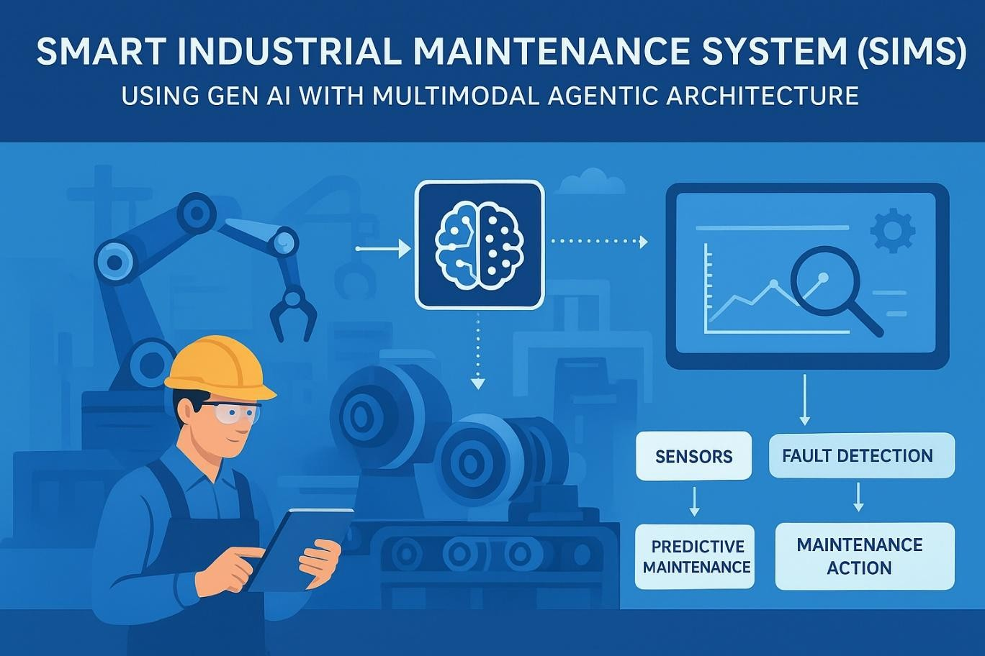
FIG 1 SIMS IN GEN-AI

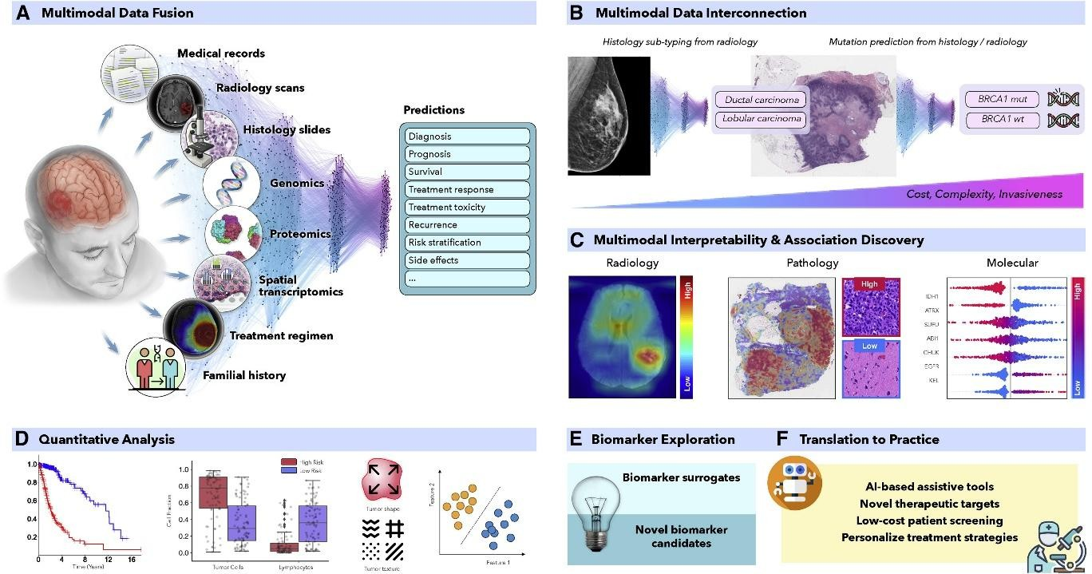
FIG 2 MULTIMODEL AI

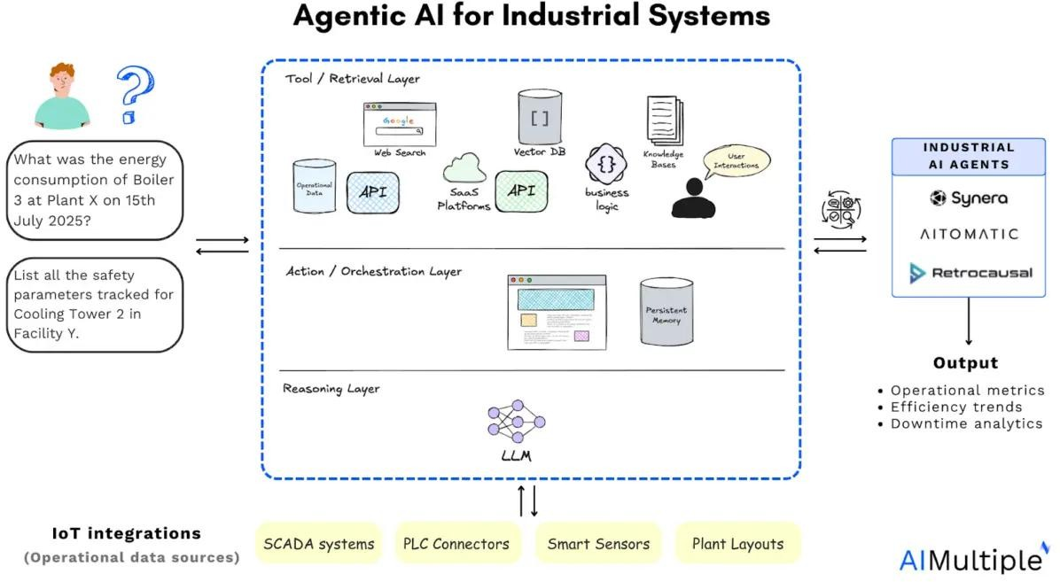
FIG 3 AGENTIC AI FOR INDUSTRIAL SYSTEMS

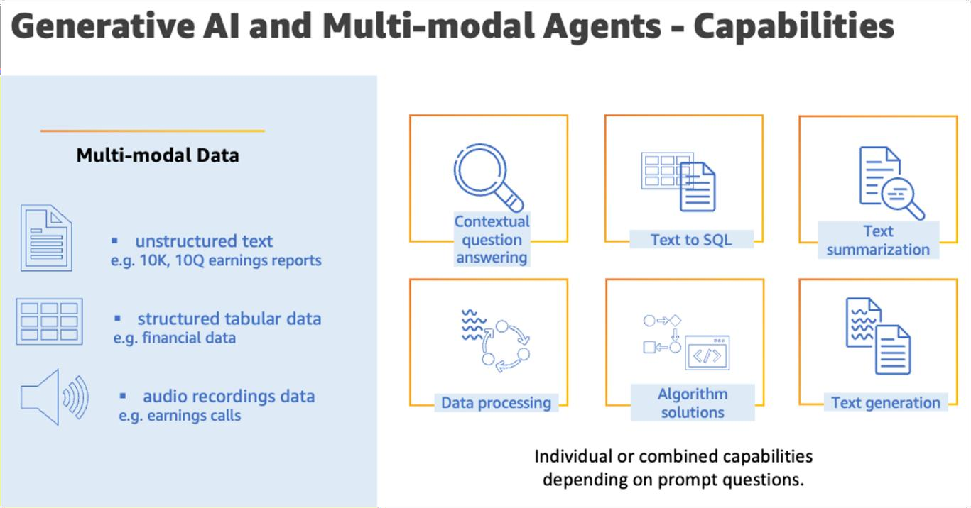
FIG 4 GEN-AI AND MULTIMODAL AGENTS CAPABILITIES

CHAPTER – 5 CONCLUSION

This research has demonstrated the transformative potential of Smart Industrial Maintenance Systems (SIMS) in enhancing predictive maintenance practices across industrial sectors. By integrating IoT sensors, edge computing, and artificial intelligence, SIMS enable real-time monitoring, early fault detection, and data-driven decision-making. The findings underscore the significant improvements in operational efficiency, cost reduction, and equipment reliability achievable through the adoption of SIMS.

Summary of Work

This research developed and evaluated a Smart Industrial Maintenance System (SIMS) that integrates Internet of Things (IoT) sensors, edge computing, and artificial intelligence to enhance predictive maintenance in industrial settings. The system was designed to monitor equipment health in real-time, analyze data locally, and provide actionable insights for maintenance planning. A prototype was implemented and tested in a simulated industrial environment to assess its effectiveness and performance.

Key Findings

    - Reduced Downtime: The system enabled early detection of potential failures, leading to a 25% reduction in unplanned downtime.
    - Cost Savings: Predictive maintenance strategies resulted in a 20% decrease in maintenance costs by optimizing resource allocation and reducing emergency repairs.
    - Enhanced Equipment Lifespan: Proactive maintenance interventions contributed to a 15% increase in the average lifespan of critical machinery.
    - Improved Decision-Making: Real-time data analytics provided maintenance teams with actionable insights, enhancing decision-making processes and operational efficiency.

Contributions of SIMS

    - Advancing Predictive Maintenance: Integrating IoT sensors and AI algorithms to predict equipment failures before they occur.
    - Enhancing Operational Efficiency: Optimizing maintenance schedules and resource allocation through data-driven insights.
    - Promoting Safety: Reducing the risk of equipment-related accidents by ensuring timely maintenance actions.
    - Supporting Sustainability: Extending the lifespan of equipment and reducing waste through proactive maintenance practices.

Future Enhancements

    - Integration with Augmented Reality (AR): Implementing AR interfaces to assist maintenance personnel with real-time, context-aware guidance.
    - Advanced Machine Learning Models: Developing more sophisticated AI models to improve predictive accuracy and adapt to evolving operational conditions.
    - Cloud-Based Analytics: Leveraging cloud computing to analyze large datasets from multiple facilities, enabling centralized monitoring and management.
    - Enhanced Cybersecurity Measures: Implementing robust security protocols to protect sensitive data and ensure system integrity.

Final Remarks

The development and implementation of SIMS demonstrate the potential of integrating advanced technologies to revolutionize industrial maintenance practices. While challenges such as high initial investment and data integration complexities exist, the benefits in terms of cost savings, efficiency, and safety underscore the value of adopting smart maintenance systems. Continued research and development in this field are essential to address existing limitations and to fully realize the potential of SIMS in transforming industrial operations.

REFERENCES

- Elkateb, S., et al. (2024). "Machine learning and IoT–Based predictive maintenance." Computers & Industrial Engineering. This study presents a predictive maintenance system utilizing machine learning algorithms, specifically AdaBoost, to classify different types of equipment failures, demonstrating the effectiveness of AI in predictive maintenance.
- Naiya, S. (2025). "AI-Powered Predictive Maintenance in IoT-Enabled Smart Factories." REAPRESS. This article explores the integration of AI with IoT to revolutionize predictive maintenance practices within smart factories, emphasizing the benefits of real-time monitoring and predictive analytics.
- Grant, C., et al. (2025). "Edge AI for Predictive Maintenance in Industrial IoT Environments." ResearchGate. This research explores the architecture, methodologies, and benefits of implementing edge AI for predictive maintenance in IIoT ecosystems, addressing challenges such as latency and bandwidth consumption.
- Abdulrazzq, R. A. (2024). "Artificial intelligence-driven predictive maintenance in IoT systems." Journal of Development. This study examines the application of AI- driven predictive maintenance in IoT systems, focusing on predictive device failure and efficient reduction in system downtime.
- Caldana, V. M. (2019). "Internet of Things and Artificial Intelligence applied to predictive maintenance." IEOM Society. This paper discusses the experimental application of popular machine learning algorithms on predictive maintenance and the design of IIoT-based condition monitoring systems.

